Phonics plan week 9
sh ch th ng Tricky words: she he me be we
Monday  sh | - Watch the video on U-tube: https://www.youtube.com/watch?v=OfYL3drCqrk  - Write words: shop shell fish rush cash shed  - Write a sentence: I am in such rush to get to the shops.  Challenge: Extend your sentence with a conjunction: and because so but
Tuesday  ch | - Watch the video on U-TUBE:  https://www.youtube.com/watch?v=cyvq2rEsXNs  - Play game on https://www.phonicsplay.co.uk/# (use username and password provided). Go to Phase3 and choose game ‘Buried treasure’- children to segment and blend the words. Focus on words with sh and ch sound.  - Write s sentence: Lots of shops sell chicken as well as fish and chips.  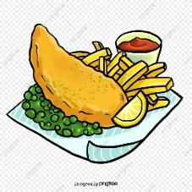
Wednesday  th | - Watch video on U-TUBE: https://www.youtube.com/watch?v=4nsY1o85MjM  - Write words: them this that moth thin bath path  - Write a sentence: A moth can be fat, but its wings are thin.  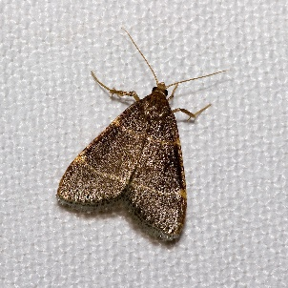  Challenge: What else do you know about moths? Write a sentence.
Thursday  ng | - Watch video on U-TUBE:  https://www.youtube.com/watch?v=YTm76dmmF08  - Play game on https://www.phonicsplay.co.uk/ (use username and password provided) and play game: ‘Make a match’ (with a monkey) Phase 3 with sounds: sh, ch, th, ng  - Write a sentence: Natasha sang a song to me.  Challenge: Extend a sentence with a conjunction and, because so or but.
Friday  Tricky words:  she he me be we | - Listen to the tricky words song  https://www.youtube.com/watch?v=ri4u0TjAZ38  - Practise writing tricky words: she he me we be  - Play a game with your child: make tricky words cards, take turns to pick a card- what word is it? Can you make a sentence with that tricky word.

