**Topic:**

**Art and craft ideas**: create a mini-beast of your choice using variety of resources.

[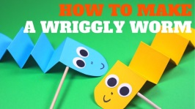](https://www.google.co.uk/url?sa=i&url=https://www.youtube.com/watch?v=xMAPpjdWQq8&psig=AOvVaw2weYWXrfmOB-YEhGk9UM6v&ust=1587215204177000&source=images&cd=vfe&ved=0CAIQjRxqFwoTCNjpv9_D7-gCFQAAAAAdAAAAABAD)[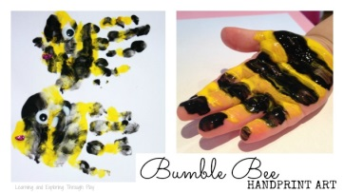](https://www.google.co.uk/url?sa=i&url=https://www.learningandexploringthroughplay.com/2015/02/bumble-bee-minibeast-handprints.html&psig=AOvVaw1_01zrYkrEZlv2mt2s0VZo&ust=1587214954795000&source=images&cd=vfe&ved=0CAIQjRxqFwoTCLCP_uvC7-gCFQAAAAAdAAAAABAR)[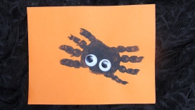](https://www.google.co.uk/url?sa=i&url=https://www.woodlandtrust.org.uk/blog/2019/06/minibeast-activities-crafts/&psig=AOvVaw1_01zrYkrEZlv2mt2s0VZo&ust=1587214954795000&source=images&cd=vfe&ved=0CAIQjRxqFwoTCLCP_uvC7-gCFQAAAAAdAAAAABAK)[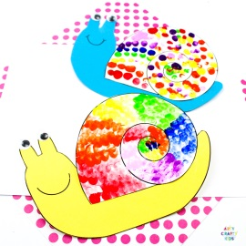](https://www.google.co.uk/url?sa=i&url=https://www.artycraftykids.com/craft/minibeast-fingerprint-snail-craft/&psig=AOvVaw1_01zrYkrEZlv2mt2s0VZo&ust=1587214954795000&source=images&cd=vfe&ved=0CAIQjRxqFwoTCLCP_uvC7-gCFQAAAAAdAAAAABAD)